**Data Structure and Algorithms - Linked List**

A linked list is a sequence of data structures, which are connected together via links.

Linked List is a sequence of links which contains items. Each link contains a connection to another link. Linked list is the second most-used data structure after array. Following are the important terms to understand the concept of Linked List.

* **Link** − Each link of a linked list can store a data called an element.
* **Next** − Each link of a linked list contains a link to the next link called Next.
* **LinkedList** − A Linked List contains the connection link to the first link called First.

## Linked List Representation

Linked list can be visualized as a chain of nodes, where every node points to the next node.

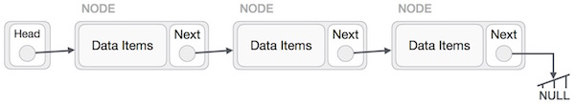

As per the above illustration, following are the important points to be considered.

* Linked List contains a link element called first.
* Each link carries a data field(s) and a link field called next.
* Each link is linked with its next link using its next link.
* Last link carries a link as null to mark the end of the list.

## Types of Linked List

Following are the various types of linked list.

* **Simple Linked List** − Item navigation is forward only.
* **Doubly Linked List** − Items can be navigated forward and backward.
* **Circular Linked List** − Last item contains link of the first element as next and the first element has a link to the last element as previous.

## Basic Operations

Following are the basic operations supported by a list.

* **Insertion** − Adds an element at the beginning of the list.
* **Deletion** − Deletes an element at the beginning of the list.
* **Display** − Displays the complete list.
* **Search** − Searches an element using the given key.
* **Delete** − Deletes an element using the given key.

## Insertion Operation

Adding a new node in linked list is a more than one step activity. We shall learn this with diagrams here. First, create a node using the same structure and find the location where it has to be inserted.

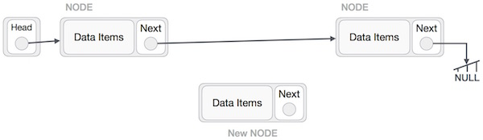

Imagine that we are inserting a node **B** (NewNode), between **A** (LeftNode) and **C** (RightNode). Then point B.next to C −

NewNode.next −> RightNode;

It should look like this −

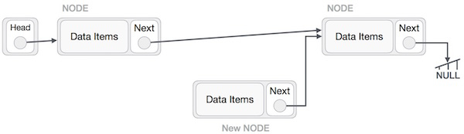

Now, the next node at the left should point to the new node.

LeftNode.next −> NewNode;

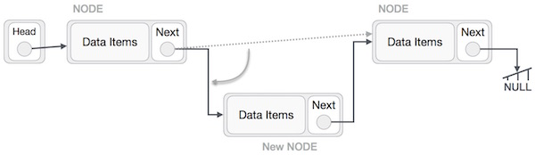

This will put the new node in the middle of the two. The new list should look like this −

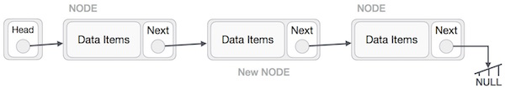

Similar steps should be taken if the node is being inserted at the beginning of the list. While inserting it at the end, the second last node of the list should point to the new node and the new node will point to NULL.

## Deletion Operation

Deletion is also a more than one step process. We shall learn with pictorial representation. First, locate the target node to be removed, by using searching algorithms.

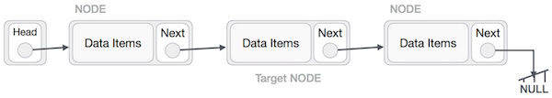

The left (previous) node of the target node now should point to the next node of the target node −

LeftNode.next −> TargetNode.next;

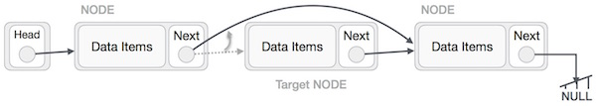

This will remove the link that was pointing to the target node. Now, using the following code, we will remove what the target node is pointing at.

TargetNode.next −> NULL;

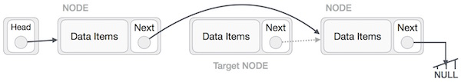

We need to use the deleted node. We can keep that in memory otherwise we can simply deallocate memory and wipe off the target node completely.

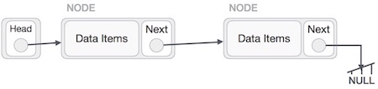

## Reverse Operation

This operation is a thorough one. We need to make the last node to be pointed by the head node and reverse the whole linked list.

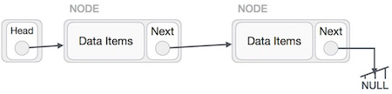

First, we traverse to the end of the list. It should be pointing to NULL. Now, we shall make it point to its previous node −

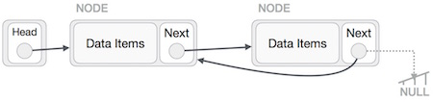

We have to make sure that the last node is not the lost node. So we'll have some temp node, which looks like the head node pointing to the last node. Now, we shall make all left side nodes point to their previous nodes one by one.

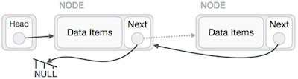

Except the node (first node) pointed by the head node, all nodes should point to their predecessor, making them their new successor. The first node will point to NULL.

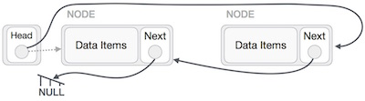

We'll make the head node point to the new first node by using the temp node.

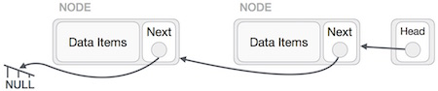

## Implementation in C

#include <stdio.h>

#include <string.h>

#include <stdlib.h>

#include <stdbool.h>

struct node {

int data;

int key;

struct node *next;

};

struct node *head = NULL;

struct node *current = NULL;

//display the list

void printList() {

struct node *ptr = head;

printf("\n[ ");

//start from the beginning

while(ptr != NULL) {

printf("(%d,%d) ",ptr->key,ptr->data);

ptr = ptr->next;

}

printf(" ]");

}

//insert link at the first location

void insertFirst(int key, int data) {

//create a link

struct node *link = (struct node*) malloc(sizeof(struct node));

link->key = key;

link->data = data;

//point it to old first node

link->next = head;

//point first to new first node

head = link;

}

//delete first item

struct node* deleteFirst() {

//save reference to first link

struct node *tempLink = head;

//mark next to first link as first

head = head->next;

//return the deleted link

return tempLink;

}

//is list empty

bool isEmpty() {

return head == NULL;

}

int length() {

int length = 0;

struct node *current;

for(current = head; current != NULL; current = current->next) {

length++;

}

return length;

}

//find a link with given key

struct node* find(int key) {

//start from the first link

struct node* current = head;

//if list is empty

if(head == NULL) {

return NULL;

}

//navigate through list

while(current->key != key) {

//if it is last node

if(current->next == NULL) {

return NULL;

} else {

//go to next link

current = current->next;

}

}

//if data found, return the current Link

return current;

}

//delete a link with given key

struct node* delete(int key) {

//start from the first link

struct node* current = head;

struct node* previous = NULL;

//if list is empty

if(head == NULL) {

return NULL;

}

//navigate through list

while(current->key != key) {

//if it is last node

if(current->next == NULL) {

return NULL;

} else {

//store reference to current link

previous = current;

//move to next link

current = current->next;

}

}

//found a match, update the link

if(current == head) {

//change first to point to next link

head = head->next;

} else {

//bypass the current link

previous->next = current->next;

}

return current;

}

void sort() {

int i, j, k, tempKey, tempData;

struct node *current;

struct node *next;

int size = length();

k = size ;

for ( i = 0 ; i < size - 1 ; i++, k-- ) {

current = head;

next = head->next;

for ( j = 1 ; j < k ; j++ ) {

if ( current->data > next->data ) {

tempData = current->data;

current->data = next->data;

next->data = tempData;

tempKey = current->key;

current->key = next->key;

next->key = tempKey;

}

current = current->next;

next = next->next;

}

}

}

void reverse(struct node** head_ref) {

struct node* prev = NULL;

struct node* current = *head_ref;

struct node* next;

while (current != NULL) {

next = current->next;

current->next = prev;

prev = current;

current = next;

}

*head_ref = prev;

}

void main() {

insertFirst(1,10);

insertFirst(2,20);

insertFirst(3,30);

insertFirst(4,1);

insertFirst(5,40);

insertFirst(6,56);

printf("Original List: ");

//print list

printList();

while(!isEmpty()) {

struct node *temp = deleteFirst();

printf("\nDeleted value:");

printf("(%d,%d) ",temp->key,temp->data);

}

printf("\nList after deleting all items: ");

printList();

insertFirst(1,10);

insertFirst(2,20);

insertFirst(3,30);

insertFirst(4,1);

insertFirst(5,40);

insertFirst(6,56);

printf("\nRestored List: ");

printList();

printf("\n");

struct node *foundLink = find(4);

if(foundLink != NULL) {

printf("Element found: ");

printf("(%d,%d) ",foundLink->key,foundLink->data);

printf("\n");

} else {

printf("Element not found.");

}

delete(4);

printf("List after deleting an item: ");

printList();

printf("\n");

foundLink = find(4);

if(foundLink != NULL) {

printf("Element found: ");

printf("(%d,%d) ",foundLink->key,foundLink->data);

printf("\n");

} else {

printf("Element not found.");

}

printf("\n");

sort();

printf("List after sorting the data: ");

printList();

reverse(&head);

printf("\nList after reversing the data: ");

printList();

}

# Data Structure - Doubly Linked List

Doubly Linked List is a variation of Linked list in which navigation is possible in both ways, either forward and backward easily as compared to Single Linked List. Following are the important terms to understand the concept of doubly linked list.

* **Link** − Each link of a linked list can store a data called an element.
* **Next** − Each link of a linked list contains a link to the next link called Next.
* **Prev** − Each link of a linked list contains a link to the previous link called Prev.
* **LinkedList** − A Linked List contains the connection link to the first link called First and to the last link called Last.

## Doubly Linked List Representation

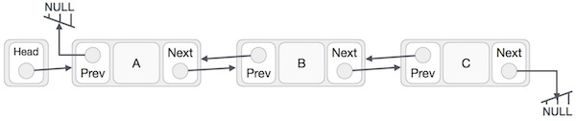

As per the above illustration, following are the important points to be considered.

* Doubly Linked List contains a link element called first and last.
* Each link carries a data field(s) and two link fields called next and prev.
* Each link is linked with its next link using its next link.
* Each link is linked with its previous link using its previous link.
* The last link carries a link as null to mark the end of the list.

## Basic Operations

Following are the basic operations supported by a list.

* **Insertion** − Adds an element at the beginning of the list.
* **Deletion** − Deletes an element at the beginning of the list.
* **Insert Last** − Adds an element at the end of the list.
* **Delete Last** − Deletes an element from the end of the list.
* **Insert After** − Adds an element after an item of the list.
* **Delete** − Deletes an element from the list using the key.
* **Display forward** − Displays the complete list in a forward manner.
* **Display backward** − Displays the complete list in a backward manner.

## Insertion Operation

Following code demonstrates the insertion operation at the beginning of a doubly linked list.

### Example

//insert link at the first location

void insertFirst(int key, int data) {

//create a link

struct node *link = (struct node*) malloc(sizeof(struct node));

link->key = key;

link->data = data;

if(isEmpty()) {

//make it the last link

last = link;

} else {

//update first prev link

head->prev = link;

}

//point it to old first link

link->next = head;

//point first to new first link

head = link;

}

## Deletion Operation

Following code demonstrates the deletion operation at the beginning of a doubly linked list.

### Example

//delete first item

struct node* deleteFirst() {

//save reference to first link

struct node *tempLink = head;

//if only one link

if(head->next == NULL) {

last = NULL;

} else {

head->next->prev = NULL;

}

head = head->next;

//return the deleted link

return tempLink;

}

## Insertion at the End of an Operation

Following code demonstrates the insertion operation at the last position of a doubly linked list.

### Example

//insert link at the last location

void insertLast(int key, int data) {

//create a link

struct node *link = (struct node*) malloc(sizeof(struct node));

link->key = key;

link->data = data;

if(isEmpty()) {

//make it the last link

last = link;

} else {

//make link a new last link

last->next = link;

//mark old last node as prev of new link

link->prev = last;

}

//point last to new last node

last = link;

}

## Implementation in C

Live Demo

#include <stdio.h>

#include <string.h>

#include <stdlib.h>

#include <stdbool.h>

struct node {

int data;

int key;

struct node *next;

struct node *prev;

};

//this link always point to first Link

struct node *head = NULL;

//this link always point to last Link

struct node *last = NULL;

struct node *current = NULL;

//is list empty

bool isEmpty() {

return head == NULL;

}

int length() {

int length = 0;

struct node *current;

for(current = head; current != NULL; current = current->next){

length++;

}

return length;

}

//display the list in from first to last

void displayForward() {

//start from the beginning

struct node *ptr = head;

//navigate till the end of the list

printf("\n[ ");

while(ptr != NULL) {

printf("(%d,%d) ",ptr->key,ptr->data);

ptr = ptr->next;

}

printf(" ]");

}

//display the list from last to first

void displayBackward() {

//start from the last

struct node *ptr = last;

//navigate till the start of the list

printf("\n[ ");

while(ptr != NULL) {

//print data

printf("(%d,%d) ",ptr->key,ptr->data);

//move to next item

ptr = ptr ->prev;

}

}

//insert link at the first location

void insertFirst(int key, int data) {

//create a link

struct node *link = (struct node*) malloc(sizeof(struct node));

link->key = key;

link->data = data;

if(isEmpty()) {

//make it the last link

last = link;

} else {

//update first prev link

head->prev = link;

}

//point it to old first link

link->next = head;

//point first to new first link

head = link;

}

//insert link at the last location

void insertLast(int key, int data) {

//create a link

struct node *link = (struct node*) malloc(sizeof(struct node));

link->key = key;

link->data = data;

if(isEmpty()) {

//make it the last link

last = link;

} else {

//make link a new last link

last->next = link;

//mark old last node as prev of new link

link->prev = last;

}

//point last to new last node

last = link;

}

//delete first item

struct node* deleteFirst() {

//save reference to first link

struct node *tempLink = head;

//if only one link

if(head->next == NULL){

last = NULL;

} else {

head->next->prev = NULL;

}

head = head->next;

//return the deleted link

return tempLink;

}

//delete link at the last location

struct node* deleteLast() {

//save reference to last link

struct node *tempLink = last;

//if only one link

if(head->next == NULL) {

head = NULL;

} else {

last->prev->next = NULL;

}

last = last->prev;

//return the deleted link

return tempLink;

}

//delete a link with given key

struct node* delete(int key) {

//start from the first link

struct node* current = head;

struct node* previous = NULL;

//if list is empty

if(head == NULL) {

return NULL;

}

//navigate through list

while(current->key != key) {

//if it is last node

if(current->next == NULL) {

return NULL;

} else {

//store reference to current link

previous = current;

//move to next link

current = current->next;

}

}

//found a match, update the link

if(current == head) {

//change first to point to next link

head = head->next;

} else {

//bypass the current link

current->prev->next = current->next;

}

if(current == last) {

//change last to point to prev link

last = current->prev;

} else {

current->next->prev = current->prev;

}

return current;

}

bool insertAfter(int key, int newKey, int data) {

//start from the first link

struct node *current = head;

//if list is empty

if(head == NULL) {

return false;

}

//navigate through list

while(current->key != key) {

//if it is last node

if(current->next == NULL) {

return false;

} else {

//move to next link

current = current->next;

}

}

//create a link

struct node *newLink = (struct node*) malloc(sizeof(struct node));

newLink->key = newKey;

newLink->data = data;

if(current == last) {

newLink->next = NULL;

last = newLink;

} else {

newLink->next = current->next;

current->next->prev = newLink;

}

newLink->prev = current;

current->next = newLink;

return true;

}

void main() {

insertFirst(1,10);

insertFirst(2,20);

insertFirst(3,30);

insertFirst(4,1);

insertFirst(5,40);

insertFirst(6,56);

printf("\nList (First to Last): ");

displayForward();

printf("\n");

printf("\nList (Last to first): ");

displayBackward();

printf("\nList , after deleting first record: ");

deleteFirst();

displayForward();

printf("\nList , after deleting last record: ");

deleteLast();

displayForward();

printf("\nList , insert after key(4) : ");

insertAfter(4,7, 13);

displayForward();

printf("\nList , after delete key(4) : ");

delete(4);

displayForward();

}

# Data Structure - Circular Linked List

Circular Linked List is a variation of Linked list in which the first element points to the last element and the last element points to the first element. Both Singly Linked List and Doubly Linked List can be made into a circular linked list.

## Singly Linked List as Circular

In singly linked list, the next pointer of the last node points to the first node.

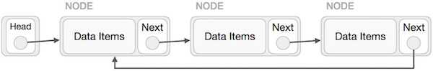

## Doubly Linked List as Circular

In doubly linked list, the next pointer of the last node points to the first node and the previous pointer of the first node points to the last node making the circular in both directions.

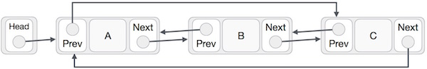

As per the above illustration, following are the important points to be considered.

* The last link's next points to the first link of the list in both cases of singly as well as doubly linked list.
* The first link's previous points to the last of the list in case of doubly linked list.

## Basic Operations

Following are the important operations supported by a circular list.

* **insert** − Inserts an element at the start of the list.
* **delete** − Deletes an element from the start of the list.
* **display** − Displays the list.

## Insertion Operation

Following code demonstrates the insertion operation in a circular linked list based on single linked list.

### Example

//insert link at the first location

void insertFirst(int key, int data) {

//create a link

struct node *link = (struct node*) malloc(sizeof(struct node));

link->key = key;

link->data= data;

if (isEmpty()) {

head = link;

head->next = head;

} else {

//point it to old first node

link->next = head;

//point first to new first node

head = link;

}

}

## Deletion Operation

Following code demonstrates the deletion operation in a circular linked list based on single linked list.

//delete first item

struct node * deleteFirst() {

//save reference to first link

struct node *tempLink = head;

if(head->next == head) {

head = NULL;

return tempLink;

}

//mark next to first link as first

head = head->next;

//return the deleted link

return tempLink;

}

## Display List Operation

Following code demonstrates the display list operation in a circular linked list.

//display the list

void printList() {

struct node *ptr = head;

printf("\n[ ");

//start from the beginning

if(head != NULL) {

while(ptr->next != ptr) {

printf("(%d,%d) ",ptr->key,ptr->data);

ptr = ptr->next;

}

}

printf(" ]");

}

## Implementation in C

Live Demo

#include <stdio.h>

#include <string.h>

#include <stdlib.h>

#include <stdbool.h>

struct node {

int data;

int key;

struct node *next;

};

struct node *head = NULL;

struct node *current = NULL;

bool isEmpty() {

return head == NULL;

}

int length() {

int length = 0;

//if list is empty

if(head == NULL) {

return 0;

}

current = head->next;

while(current != head) {

length++;

current = current->next;

}

return length;

}

//insert link at the first location

void insertFirst(int key, int data) {

//create a link

struct node *link = (struct node*) malloc(sizeof(struct node));

link->key = key;

link->data = data;

if (isEmpty()) {

head = link;

head->next = head;

} else {

//point it to old first node

link->next = head;

//point first to new first node

head = link;

}

}

//delete first item

struct node * deleteFirst() {

//save reference to first link

struct node *tempLink = head;

if(head->next == head) {

head = NULL;

return tempLink;

}

//mark next to first link as first

head = head->next;

//return the deleted link

return tempLink;

}

//display the list

void printList() {

struct node *ptr = head;

printf("\n[ ");

//start from the beginning

if(head != NULL) {

while(ptr->next != ptr) {

printf("(%d,%d) ",ptr->key,ptr->data);

ptr = ptr->next;

}

}

printf(" ]");

}

void main() {

insertFirst(1,10);

insertFirst(2,20);

insertFirst(3,30);

insertFirst(4,1);

insertFirst(5,40);

insertFirst(6,56);

printf("Original List: ");

//print list

printList();

while(!isEmpty()) {

struct node *temp = deleteFirst();

printf("\nDeleted value:");

printf("(%d,%d) ",temp->key,temp->data);

}

printf("\nList after deleting all items: ");

printList();

}